**OUTREACH SCHOOLS EXAMINATION BOARD**

**MID TERM III EXAMINATION 2023**

**TOP CLASS: (5 – 6 YEARS)**

**LEARNING AREA 3: LANGUAGE DEVELOPMENT I**

**My name is: ……………………………………………………………….**

**My School is: …………………………………….………………………..**

**I am in: ………………………………..…………………………….…………………..**

1. **Circle the correct word for the pictures.**

|  |  |
| --- | --- |
| **D:\Local Disk F\New folder\KIBUUKA 2023\pictures\DISAN PICS\pics PART 2\pics\eggs fr.jpg** | segg eggs ggse |
| **D:\Local Disk F\New folder\KIBUUKA 2023\pictures\kibuuka pic\banana 2.jpg** | nabana nanaba banana |
| **D:\Local Disk F\New folder\KIBUUKA 2023\pictures\kibuuka pic\tomato.jpg** | tomato matoto totoma |
|  | shif fish fihs |
| **D:\Local Disk F\New folder\KIBUUKA 2023\pictures\kibuuka pic\apple 2.jpg** | apple pplea eppla |

1. **Match words to pictures.**

dress

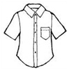

skirt

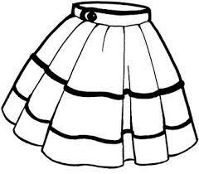

shoes

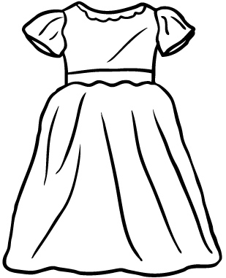

shirt

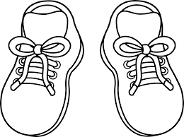

hat

1.  **Circle five dangerous objects.**

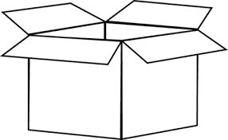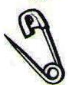



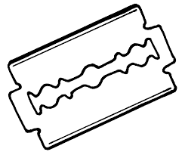

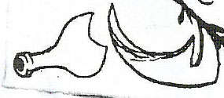

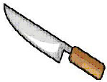

1. How many legs do you have?

_______________________________________

1. How many ears do you have?

_______________________________________

1. What do you use to smell?

_______________________________________

1. How many hands do you have?

_______________________________________

1. What do you use to see?

_______________________________________

**END**